**AWS + DevOps track Use-Case problem statement**

Here is the use case for AWS,

Automate the deployment of a simple static website (e.g., a basic HTML page) to an S3 bucket, with changes automatically picked up and deployed through a CI/CD pipeline.

1. Use terraform to provision a S3 bucket, create IAM roles for AWS CICD services.
2. Use either a GitHub repository or AWS code commit to place.
3. Create a CICD pipeline using AWS services and deploy the static website in S3 bucket.

Vardhan Mudhraboina

Employee Id: 2398027

INTCIS25CNAIP002

**AWS Usecase**

**Section-I**

Creating Files required for the project

1. Create a new repository for project.

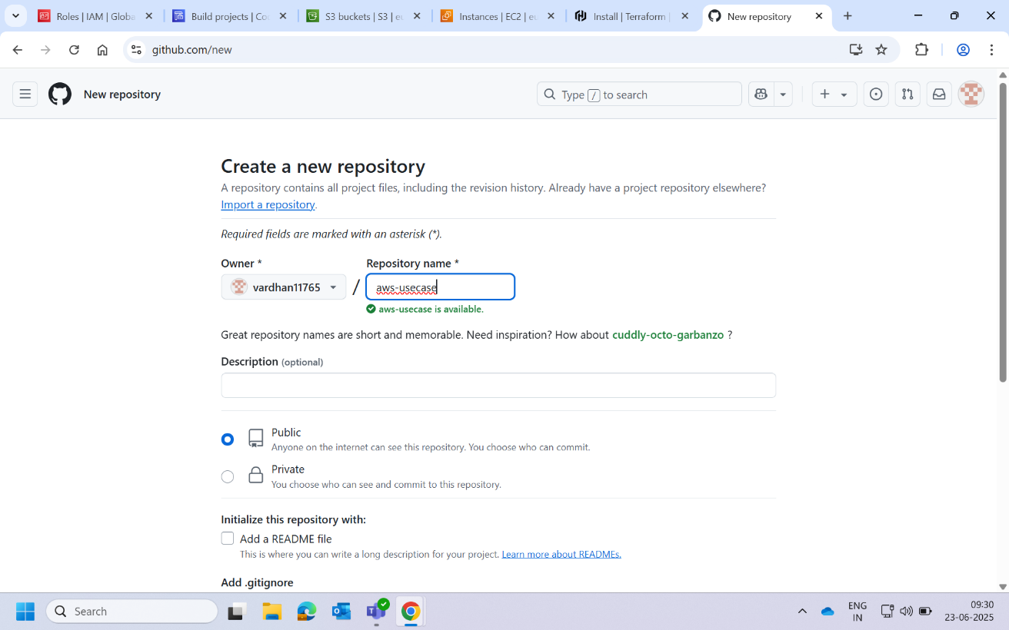

1. Create **main.tf** file to store terraform code.

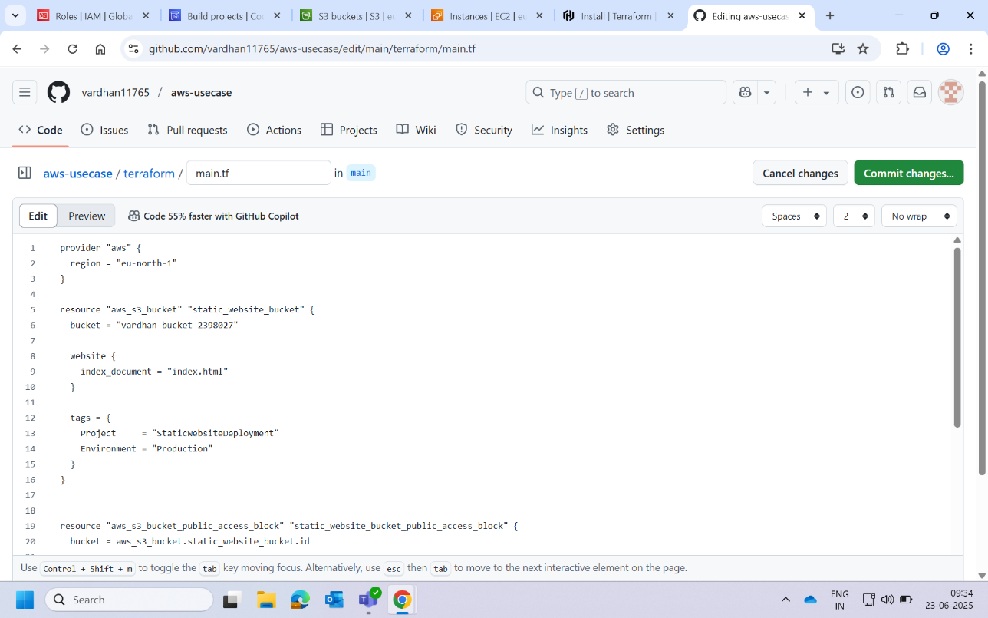

1. Create **iam.tf** file and **variables.tf** write HCL code for roles.

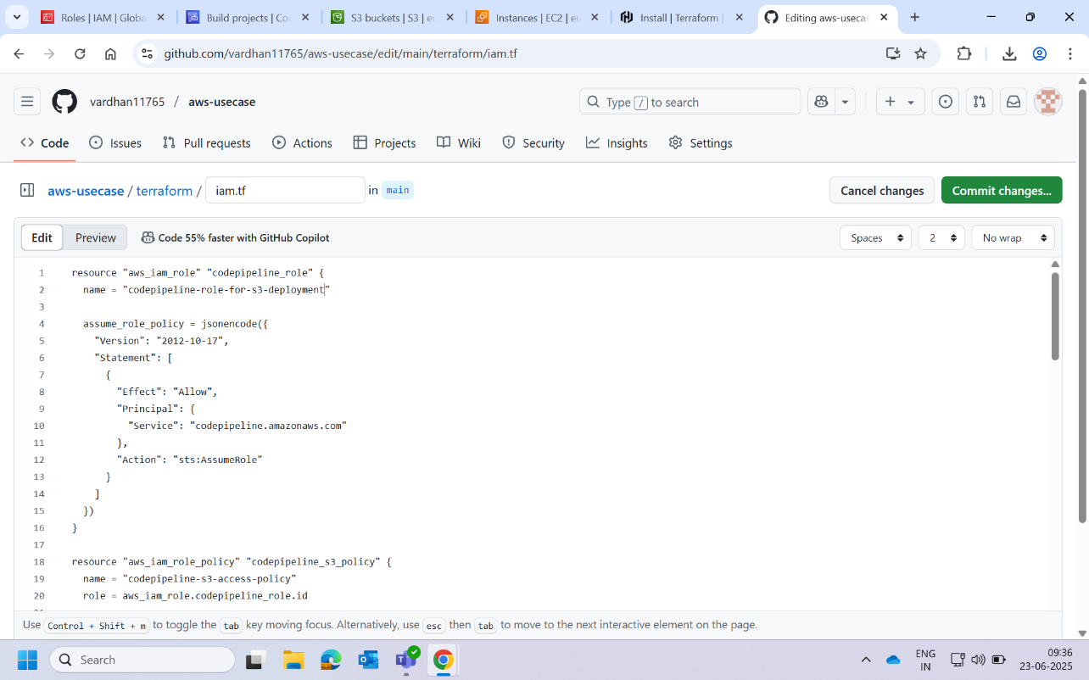

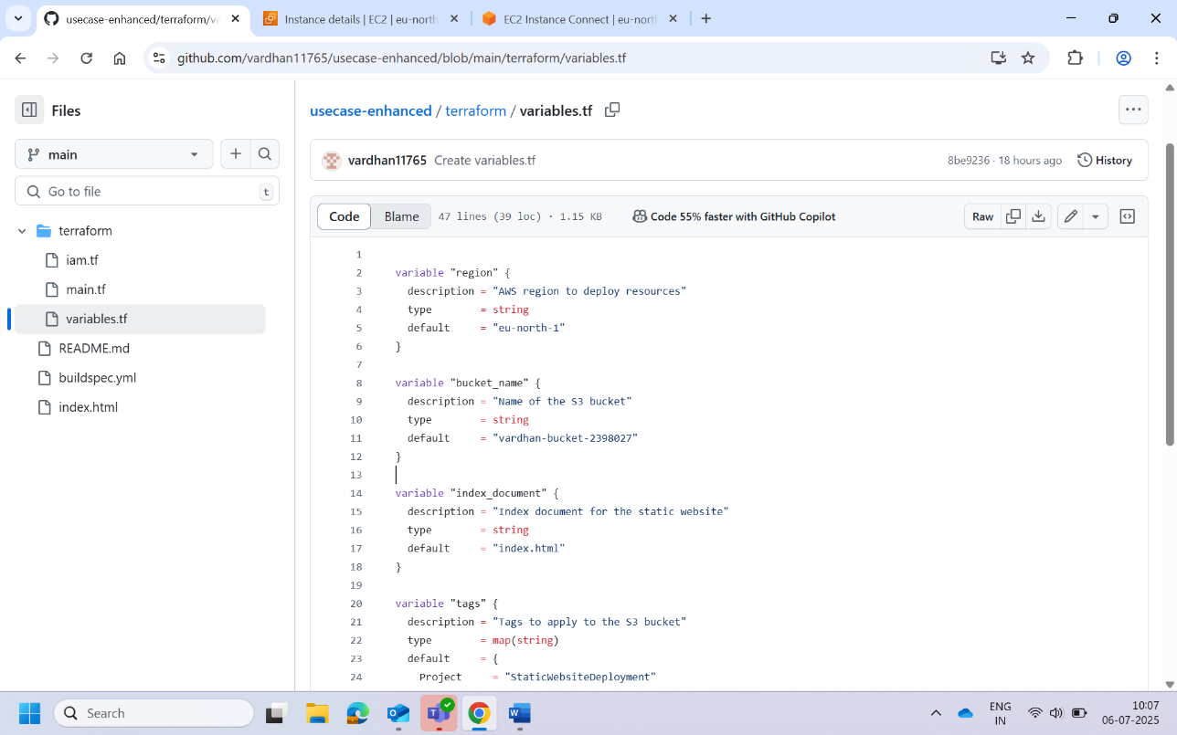

1. Create **index.html** file.

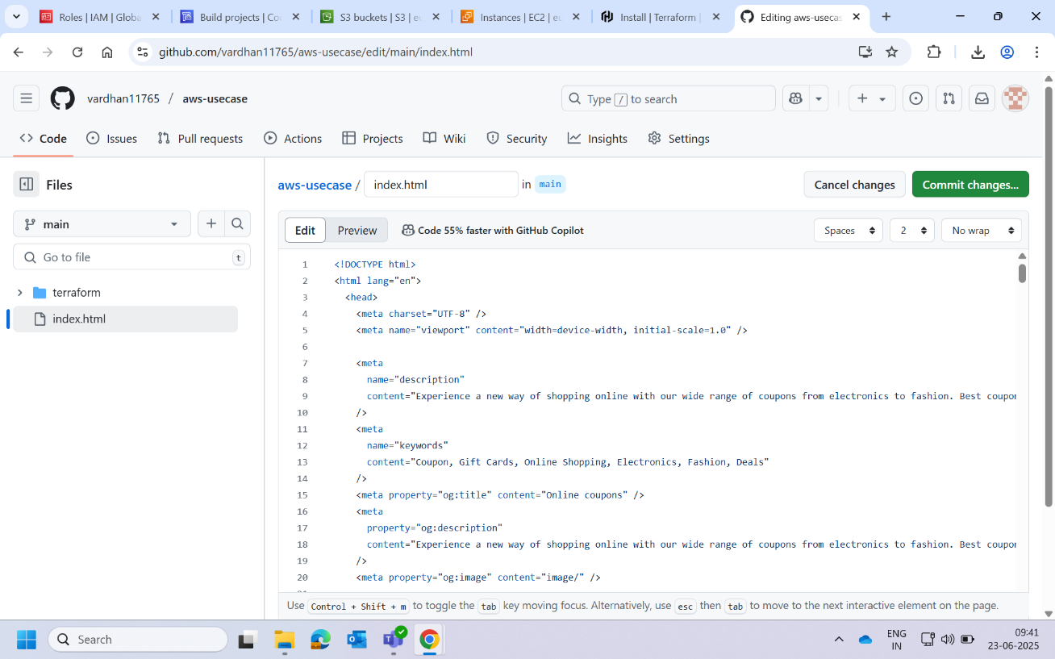

1. Create a **build_spec.yml** file

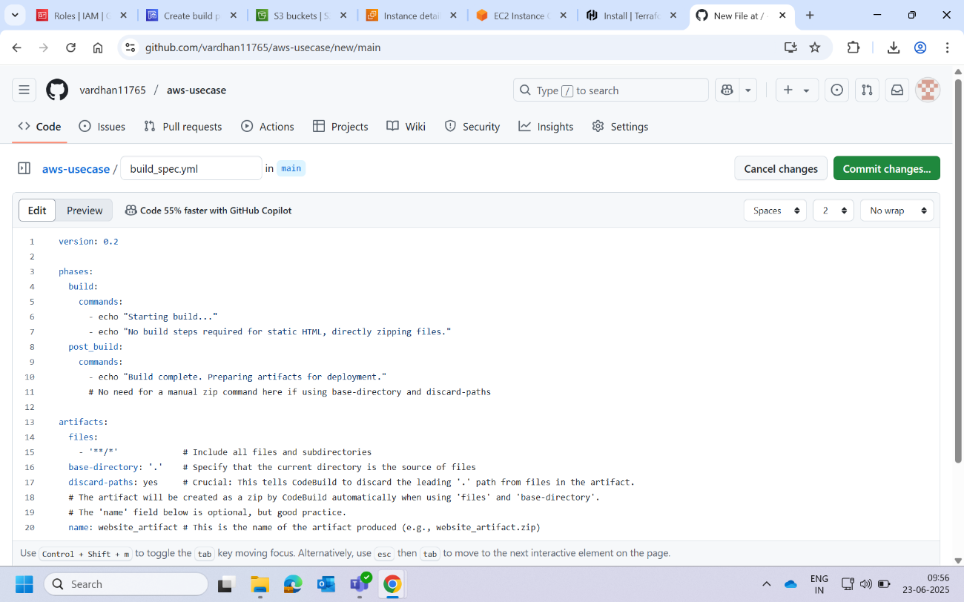

Our part of creating files has been completed. These files will help in provisioning resources in AWS, also contains our source file for website and buildspec file to create pipeline.

Here are the overall files in github.

Github

|---aws-usecase

|---index.html

|---buildspec.yml

|---terraform

|---iam.tf

|---main.tf

|---variables.tf

**Section-II**

Provisioning Resources

1. Create new EC2 instance with ubuntu ami.

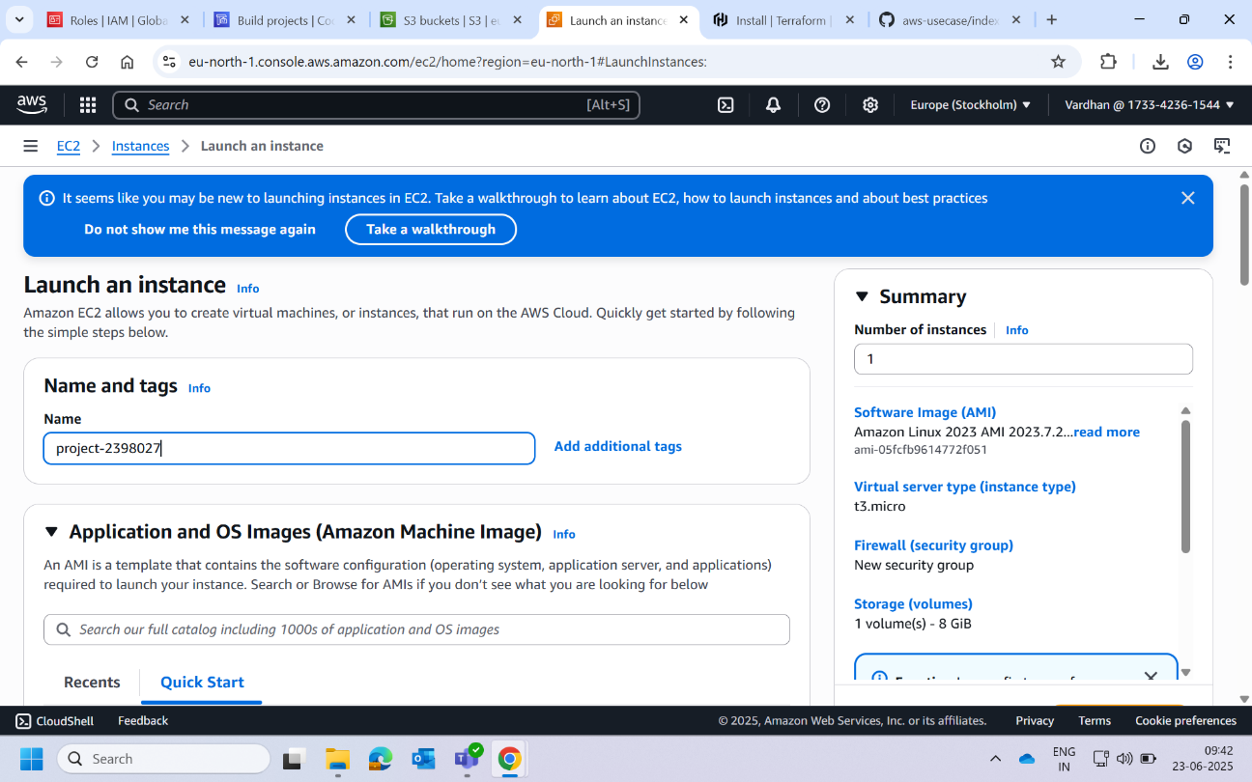

1. Select the predefined IAM instance profile as EC2FUllAccess.

Note: Crete IAM role for EC2 instance and create policy to access multiple services.

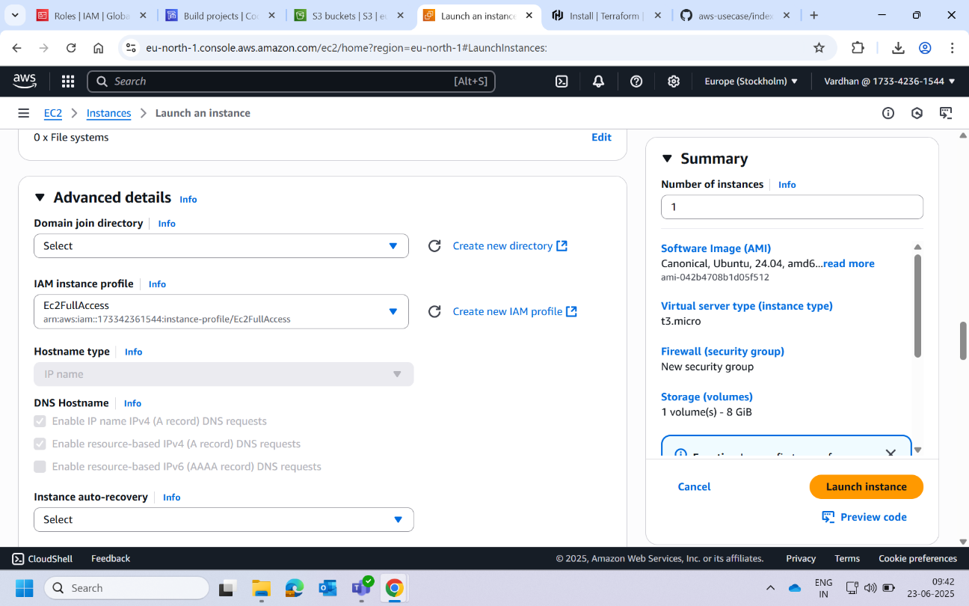

1. Connect to the EC2 instance via EC2 instance connect.

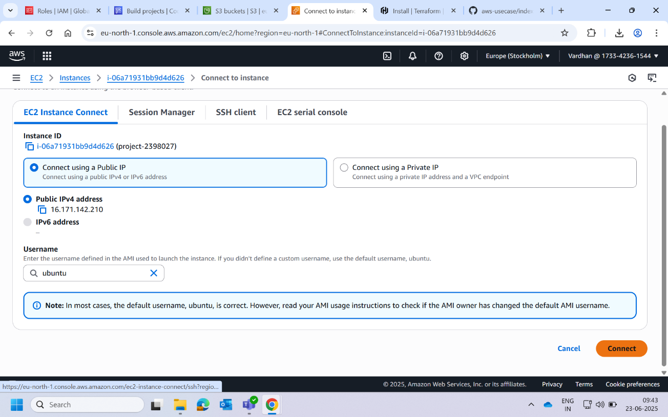

1. Go to terraform installation page and copy the package installer commands.

Source: <https://developer.hashicorp.com/terraform/install>

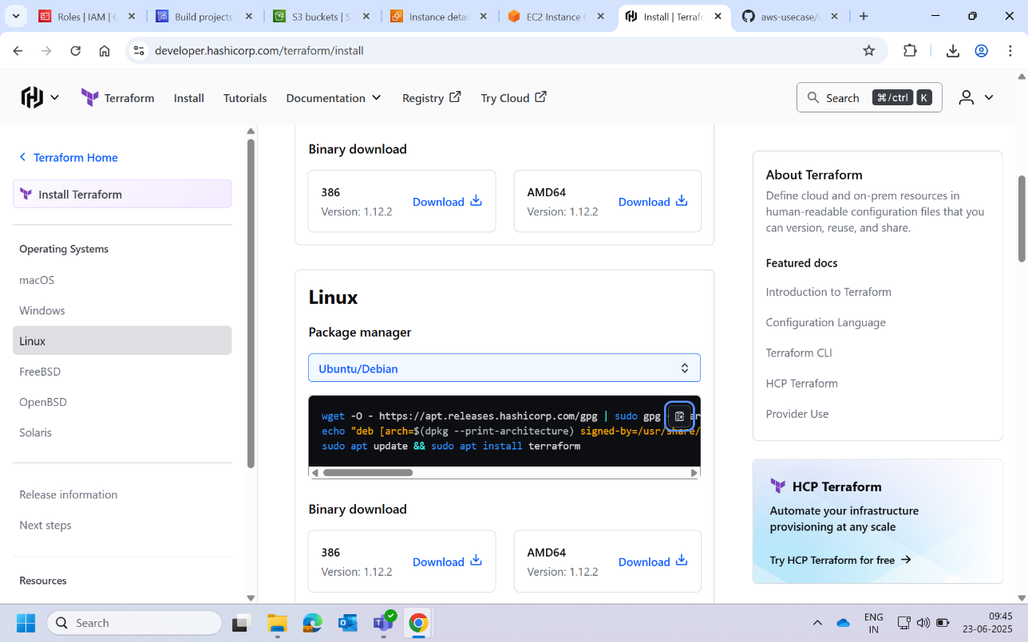

1. Paste the commands and wait for installation. After installation check weather installed by using command **terraform -v**.

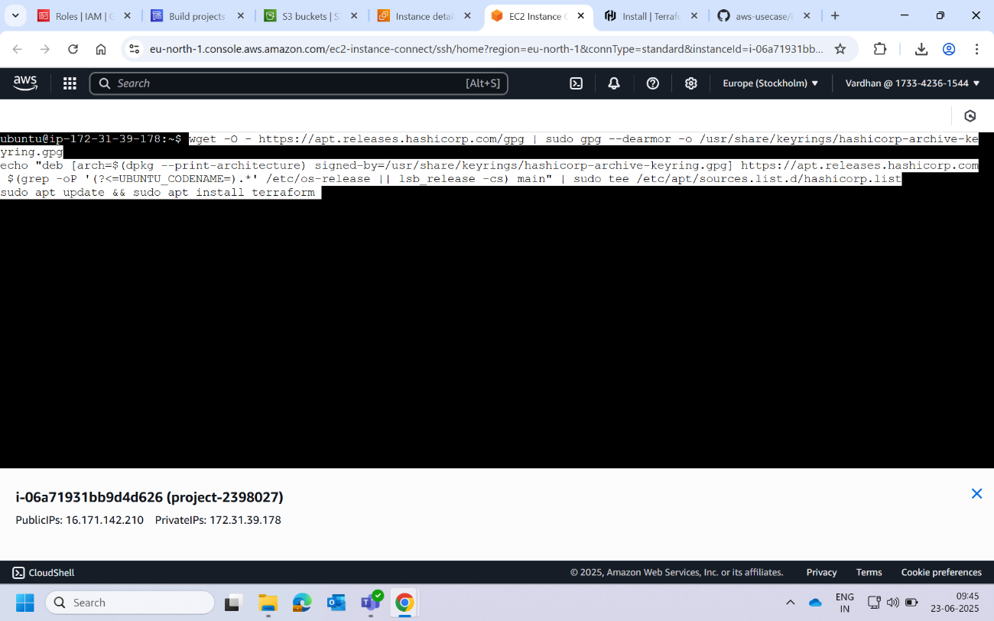

1. Copy the repository link from github to clone in our instance.

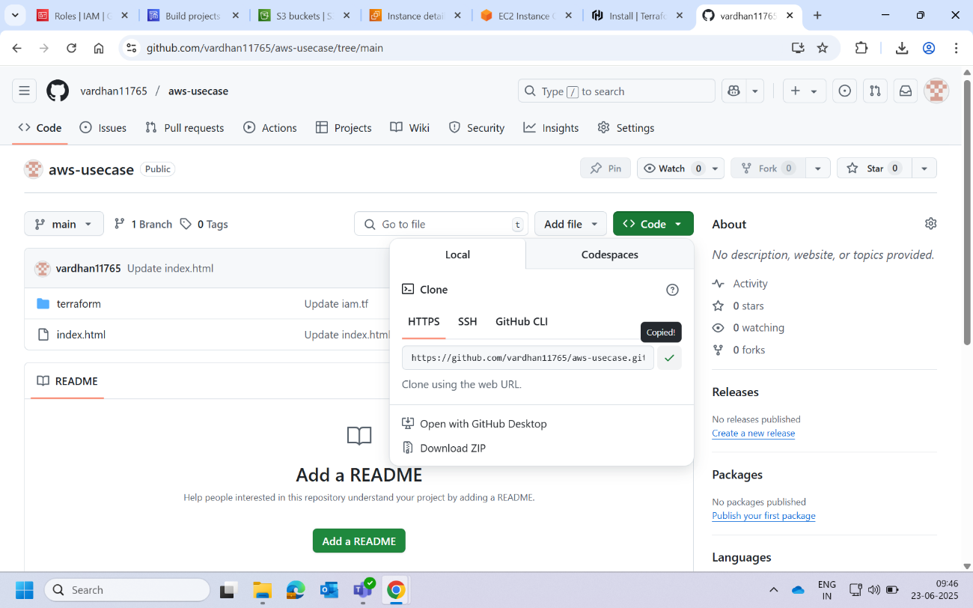

1. Clone repository in EC2 instance we created.

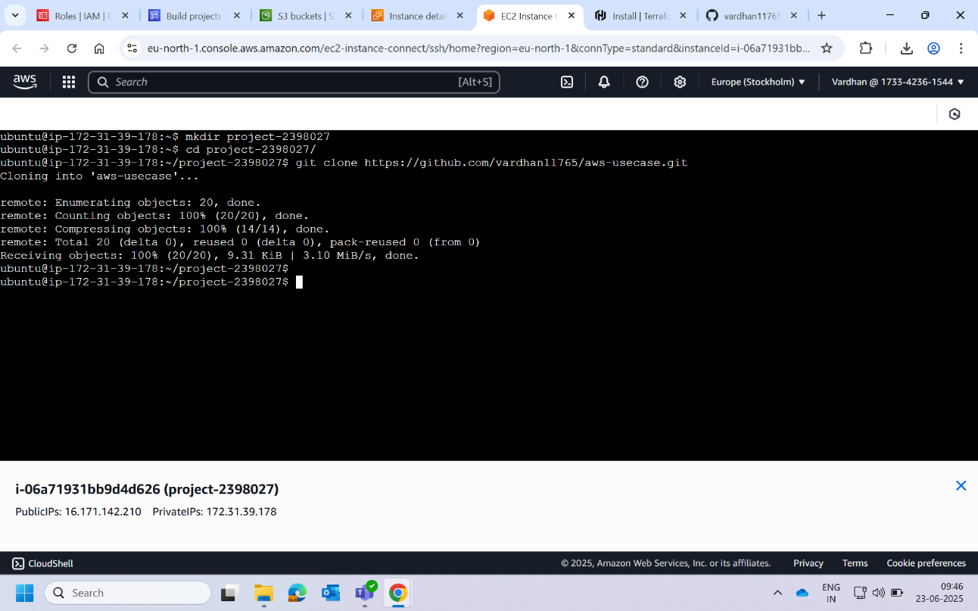

1. Run the command **terraform init** to initialize terraform. This will create the workdir for terraform.

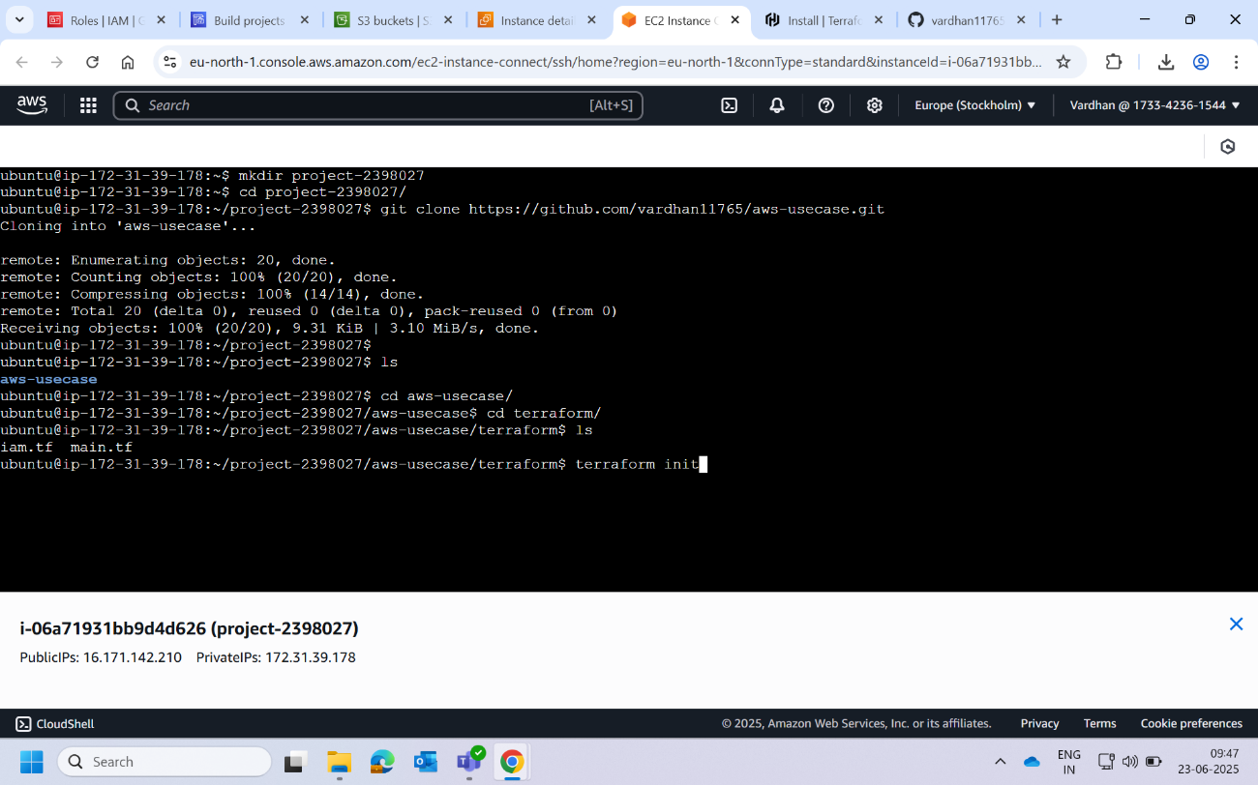

1. Terraform will be initialized. Now run the command **terraform plan**. This command will show what the code going to do. Simply it makes a dry run and shows what are the resources it will be provisioned.

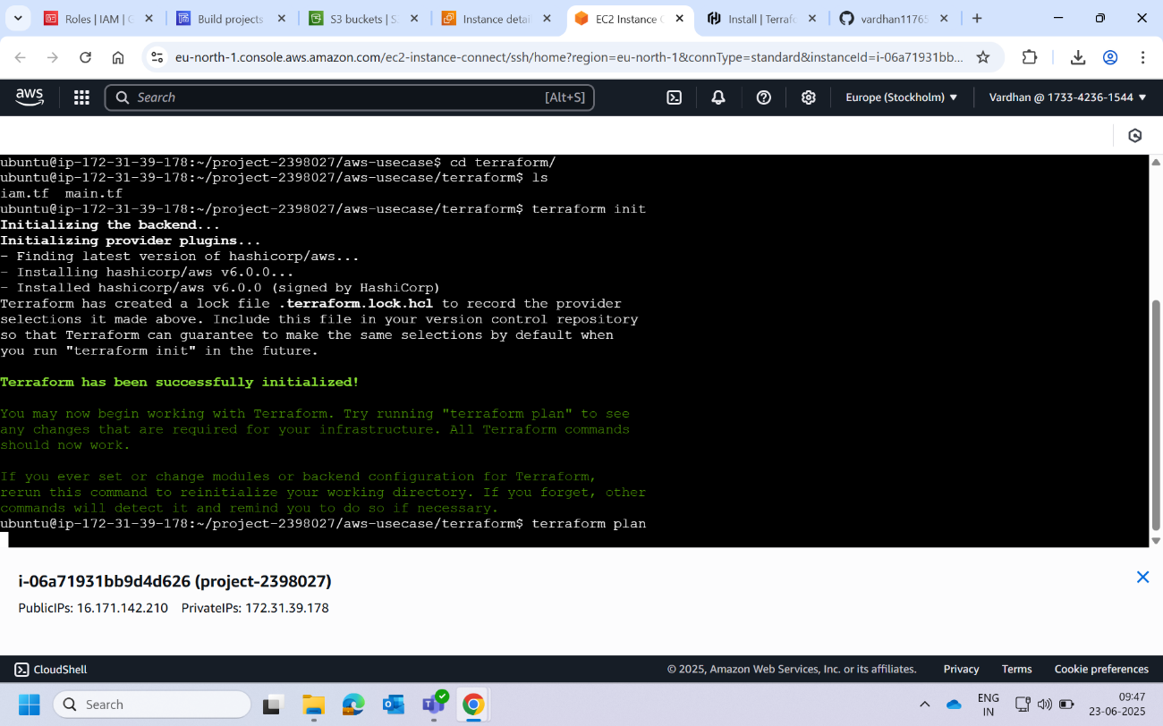

1. We can see what are the changes that code is going to make. Now run the command **terraform apply**. This will execute code and provision the resources. And also creates the state file for terraform that will show us the current state of provisioned resources.

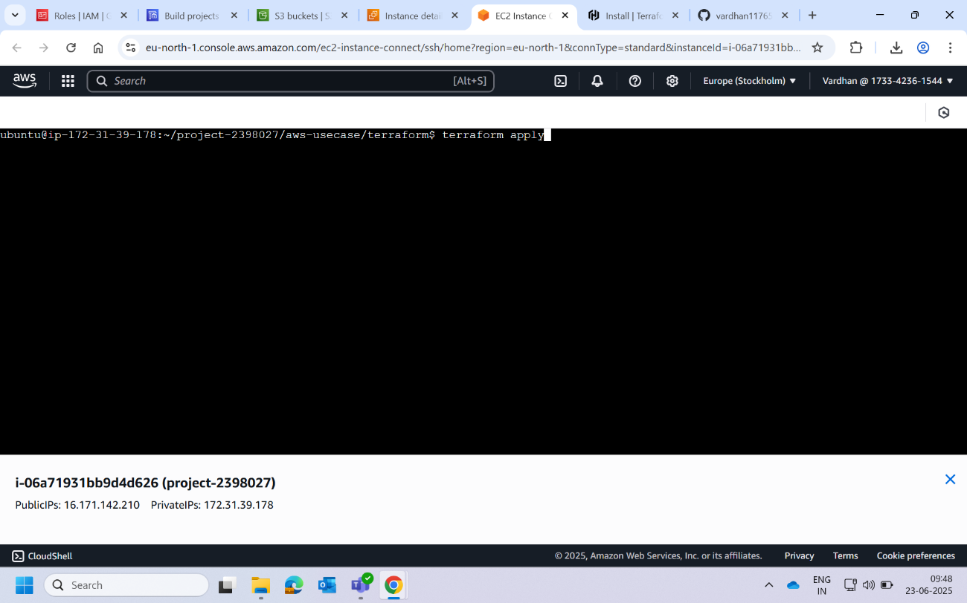

1. We can see apply complete, so our resources are created.

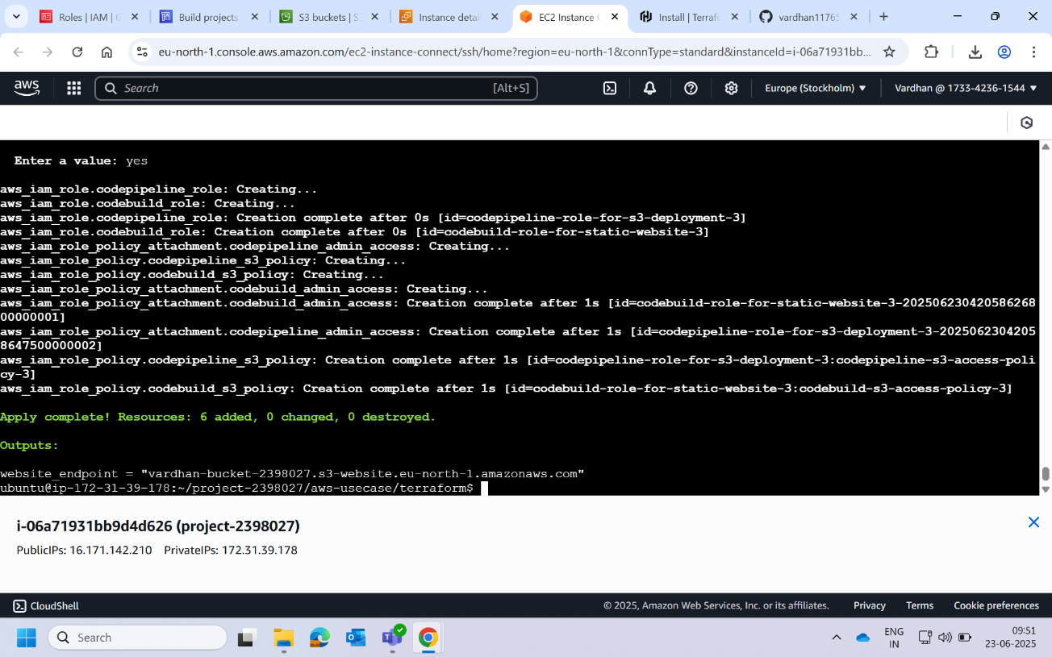

1. Check for the resources created in aws console. We can watch that S3 bucket has been created.

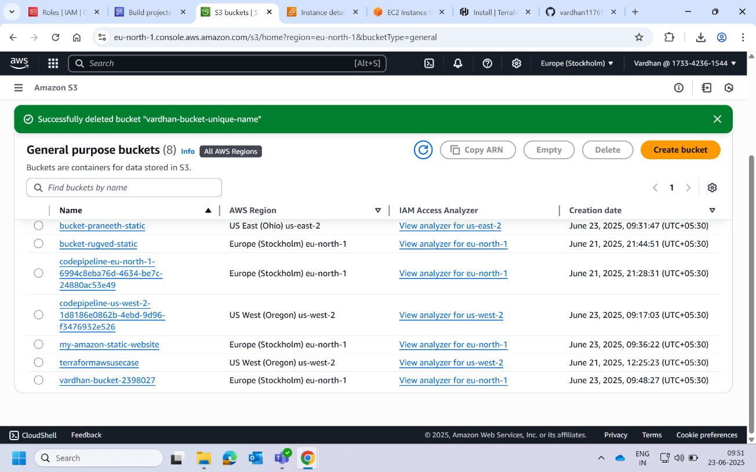

1. The roles we mentioned in iam.tf will be created. We can check them in IAM and navigating to roles.

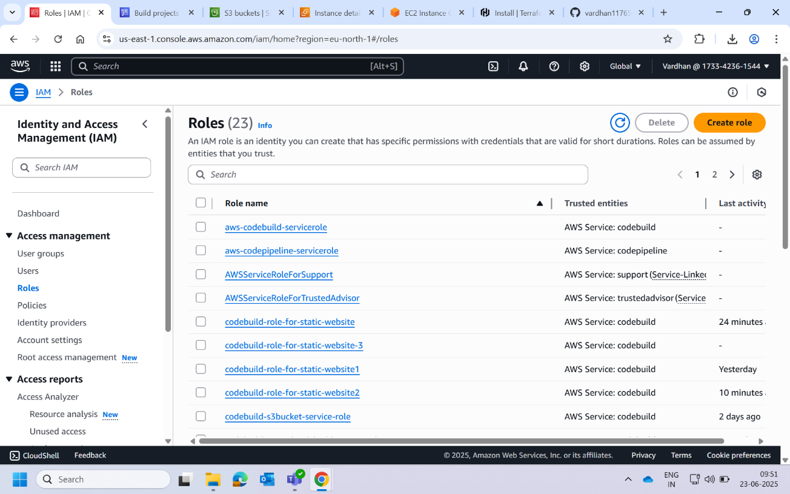

Now we have all resources for deployment and roles to create code build and code pipeline.

**Section-III**

Building and creating pipeline

1. Go to CodeBuild service. Under setting navigate to connections to connect github.

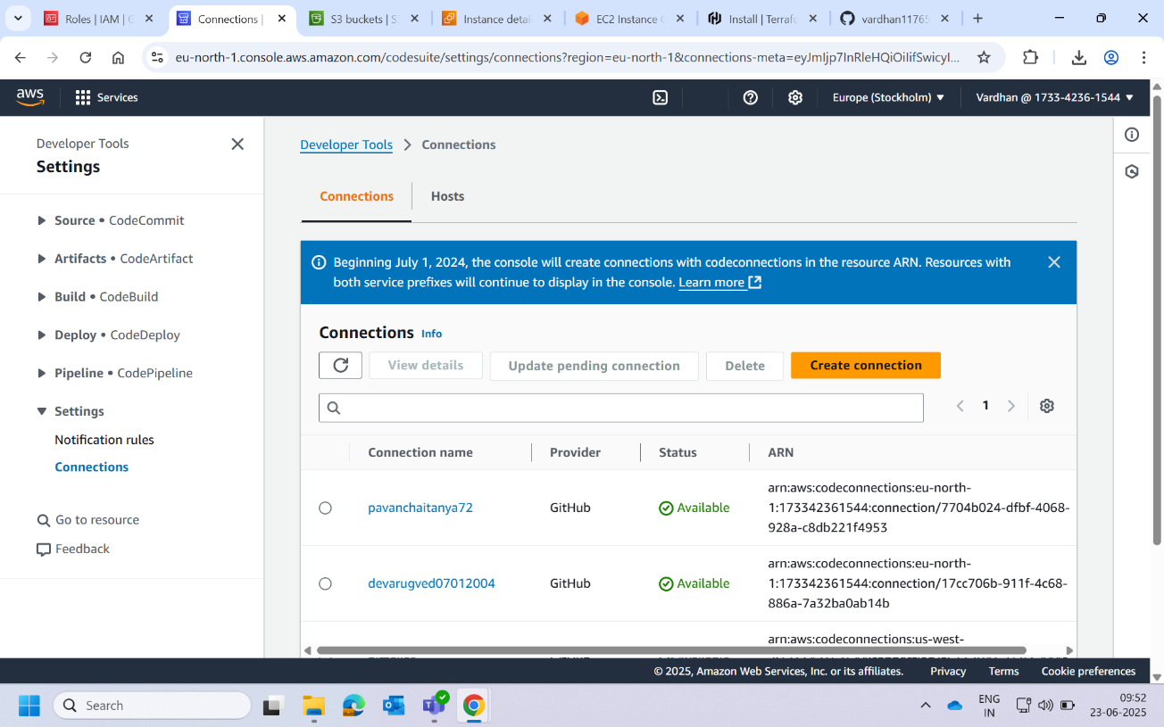

1. Connect to your github by giving authorization. Mention your github details and connect to code connection.

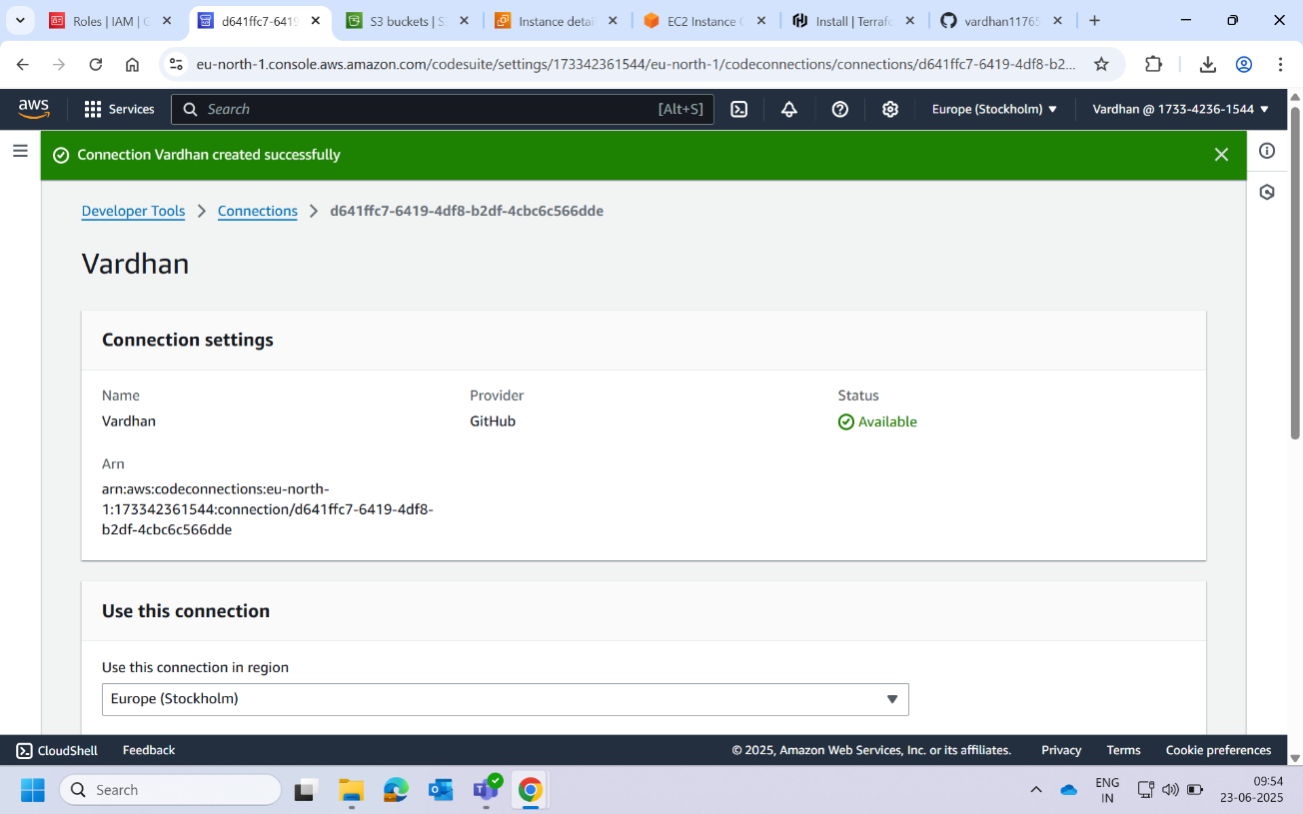

1. Now navigate to build. Under build create a new project.

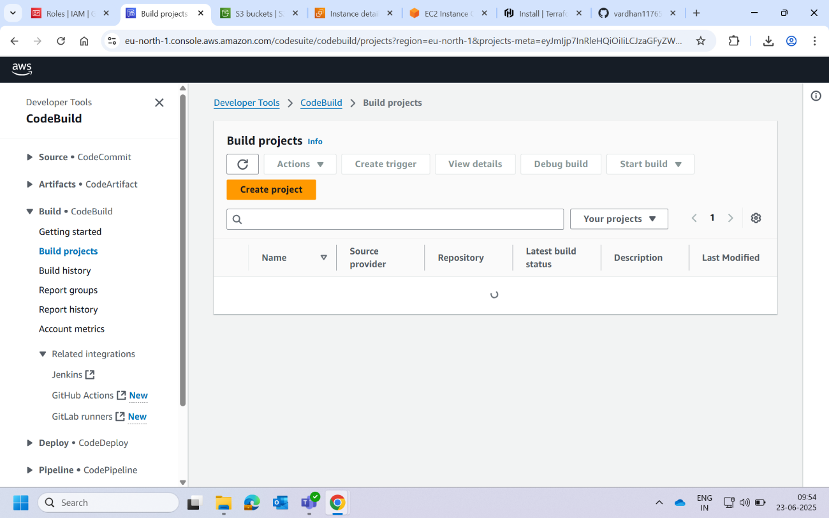

1. Give project a name and let the project type be default.

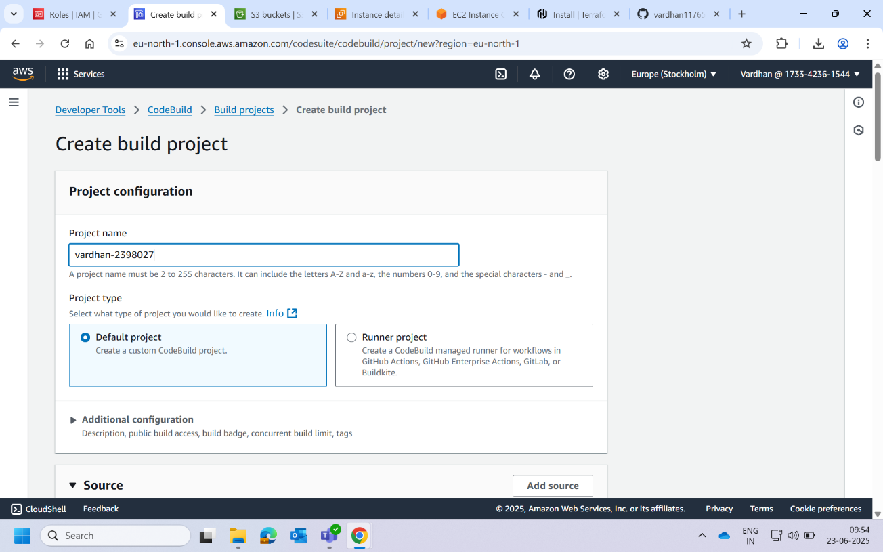

1. Give the source credentials details of your github.

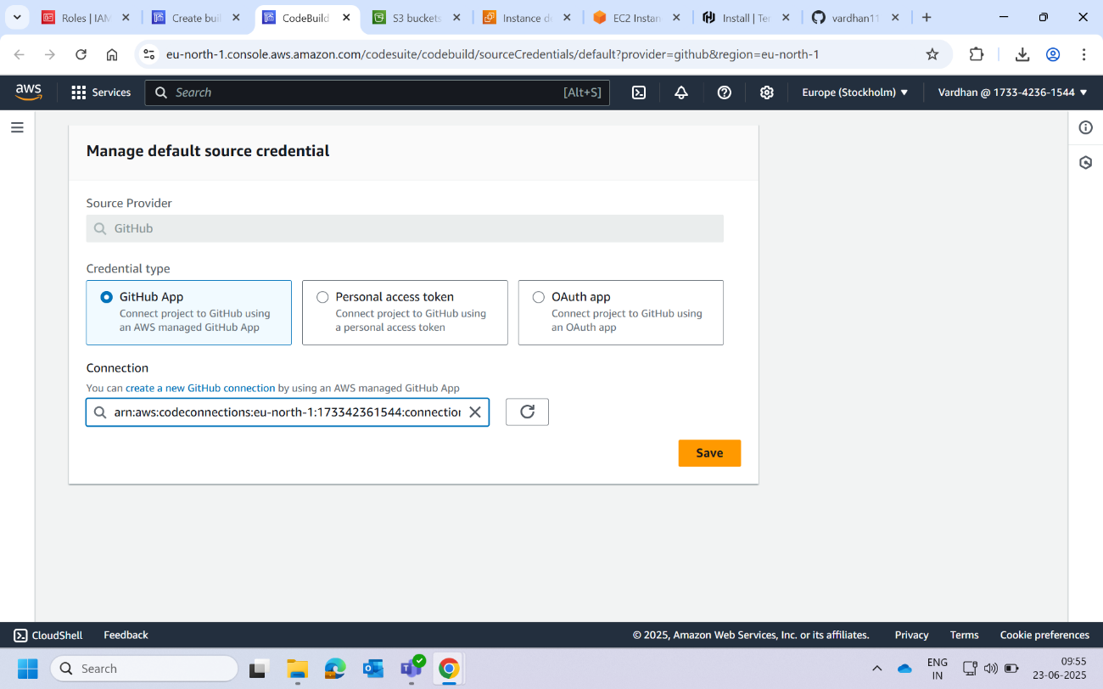

1. Select the repository we created form github and select the repository we created.

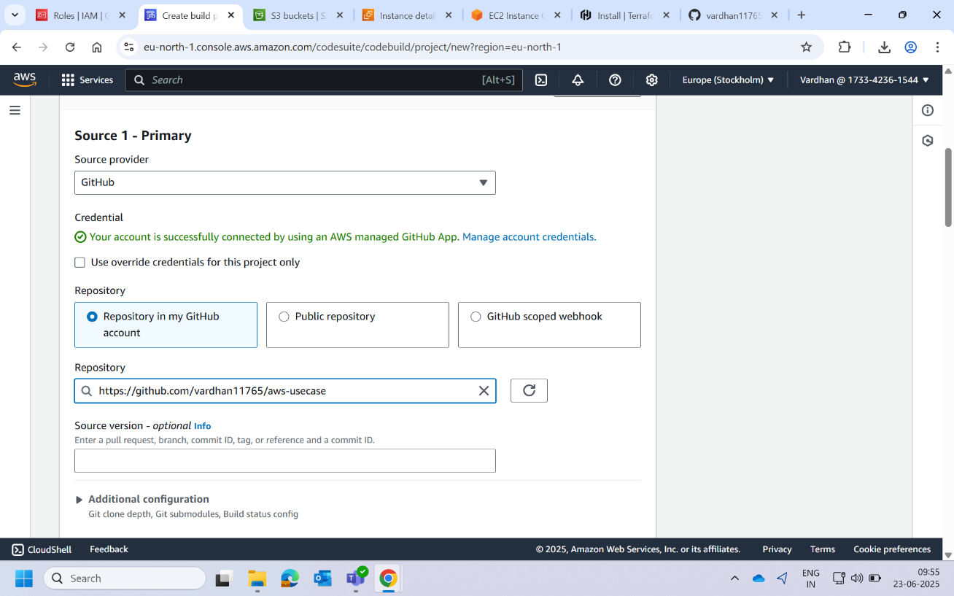

1. Choose the **webhook event** as rebuild every time a code change to the repository. This will trigger build every time there is a change in repository.

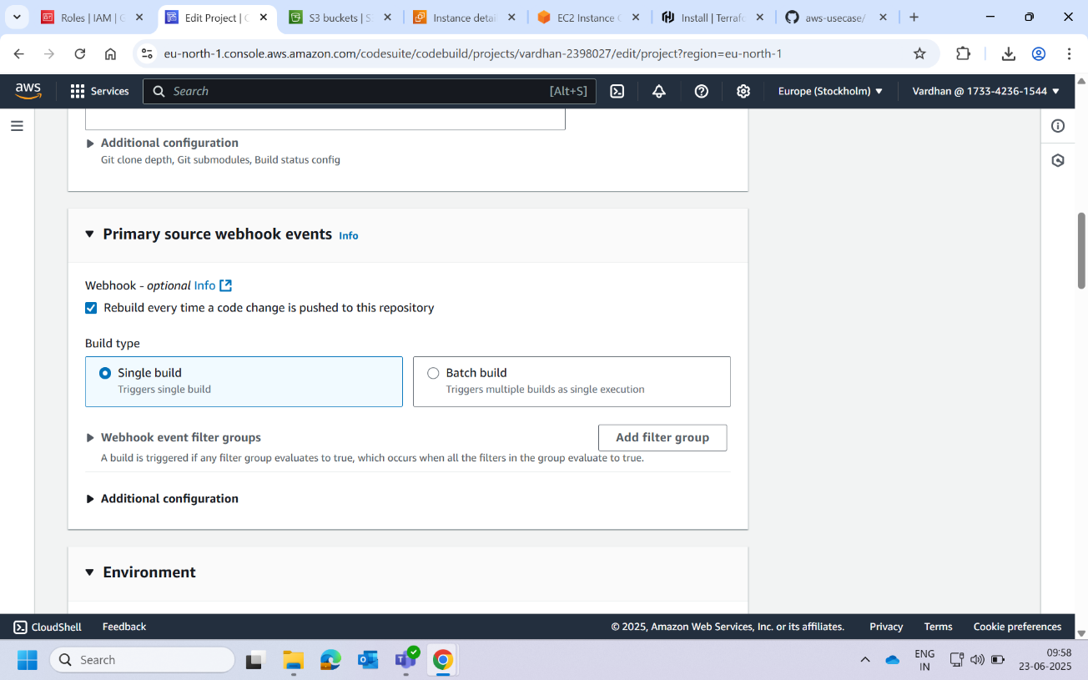

1. Our build is now created to test click on start build.

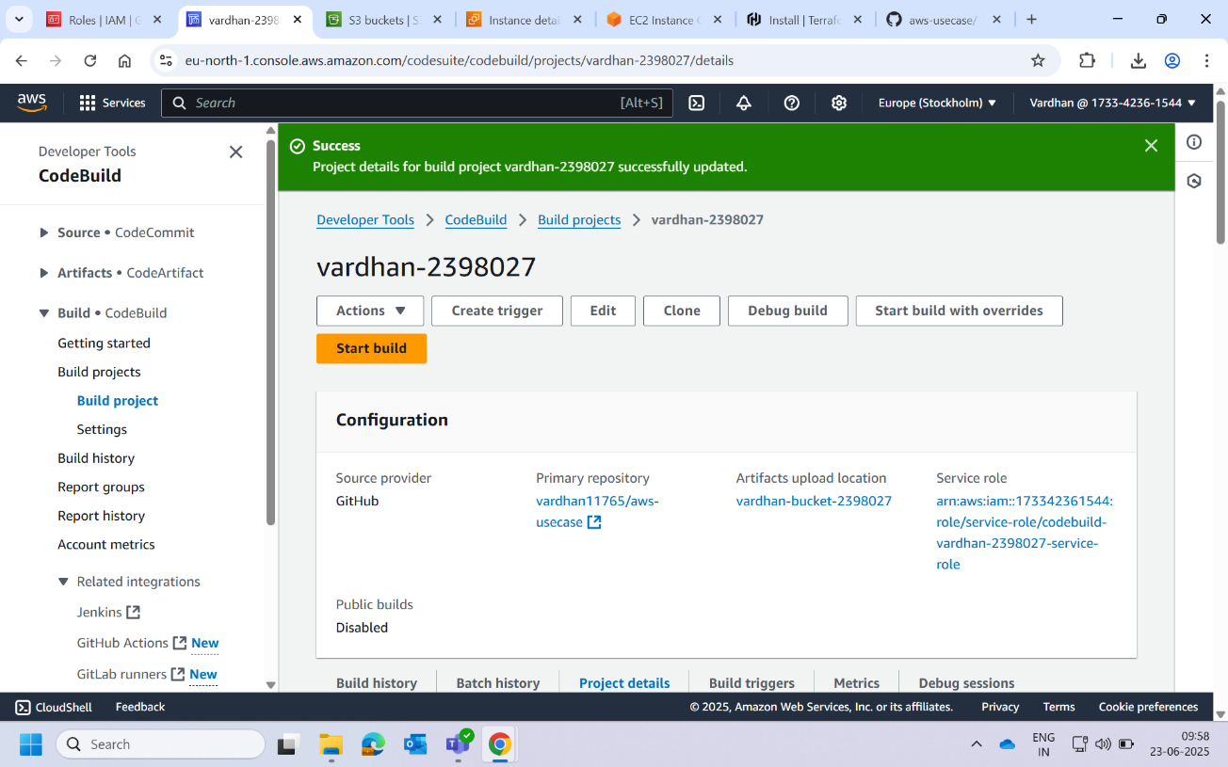

1. Now you can watch all stages of build was successful.

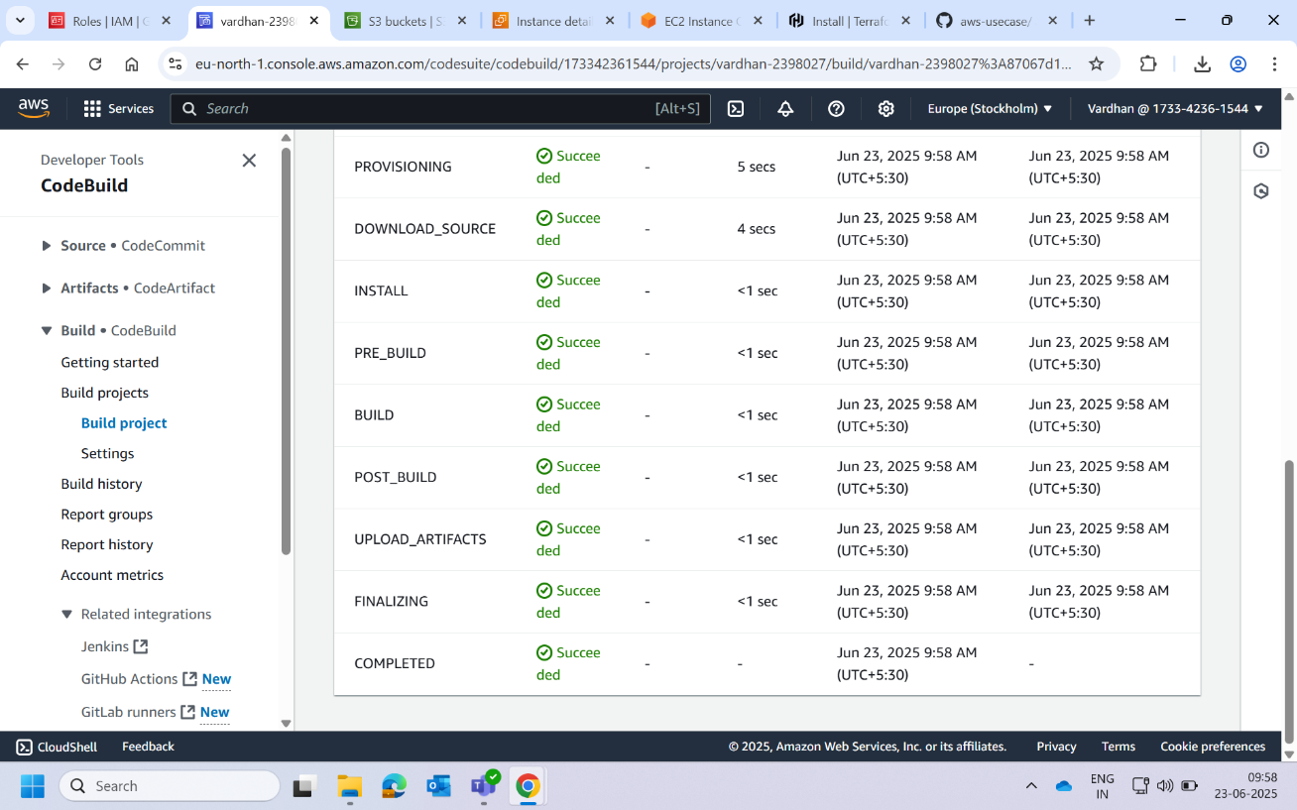

1. Navigate to **CodePipeline**. Create a new pipeline.

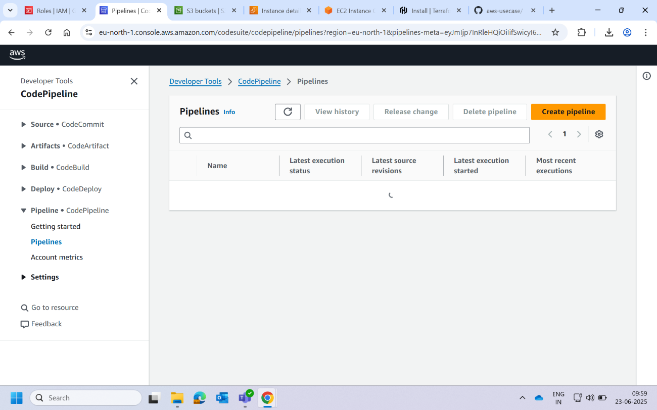

1. Choose option **build custom pipeline.**

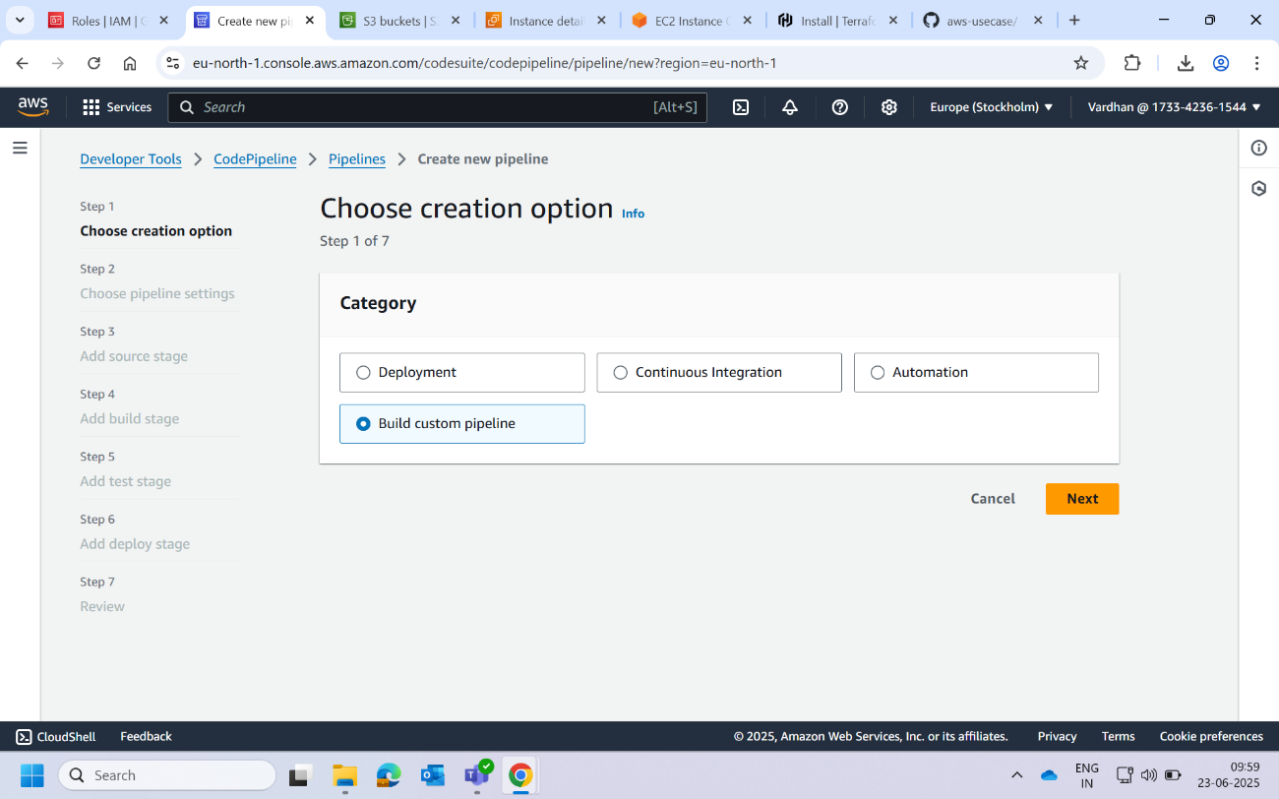

1. Choose existing service role that we created from iam.tf file we can find them in IAM roles.

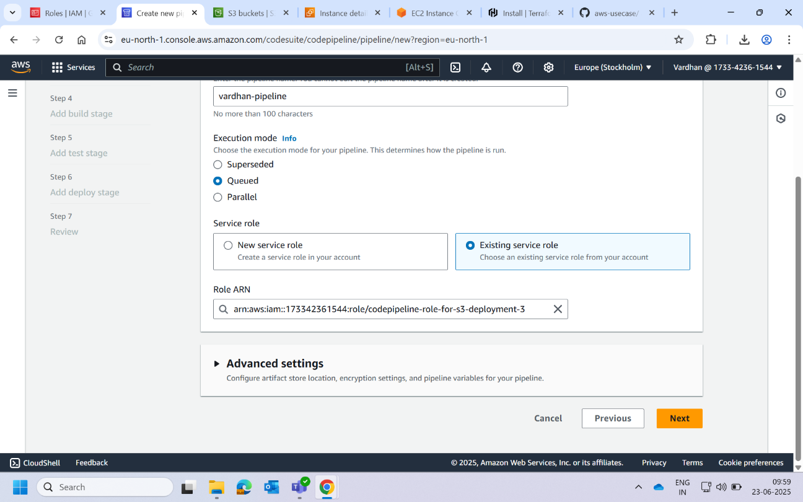

1. In source choose github(via github app). Choose the connection created and select repository. Choose main as default branch.

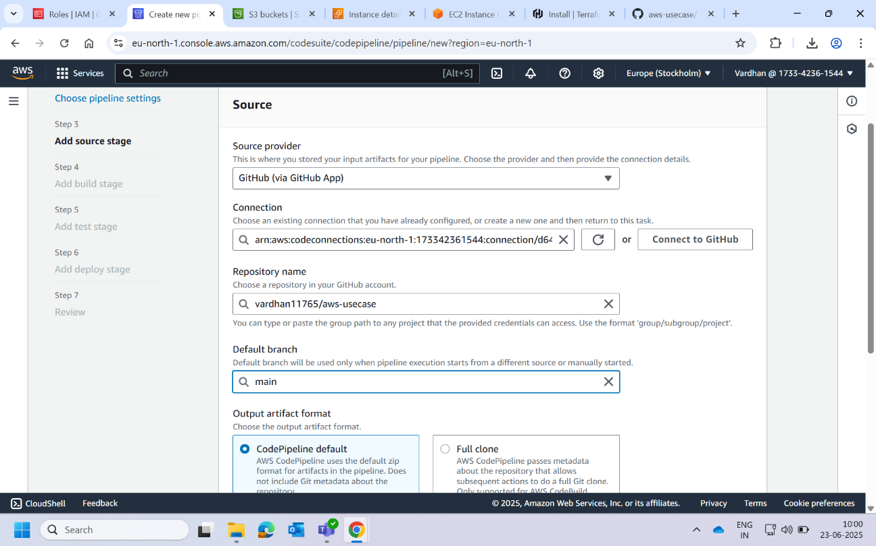

1. Use the buildspec file created in github.

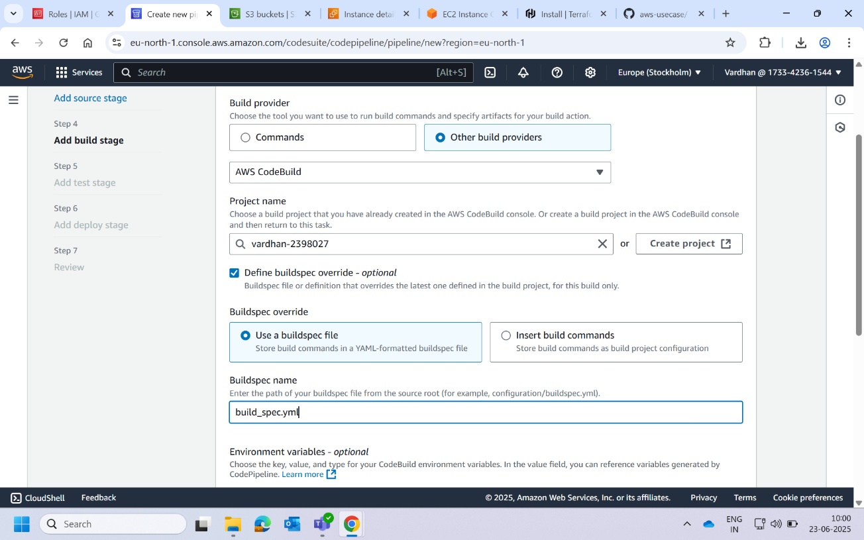

1. In deploy provider choose Amazon S3. Choose bucket name that we provisioned.

Note: S3 bucket and pipeline region should be same.

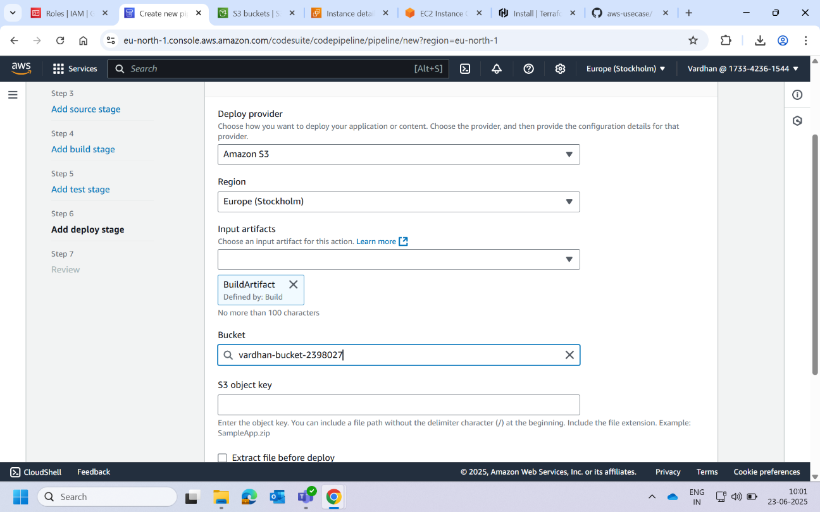

1. Review whole pipeline structure and click on create pipeline.

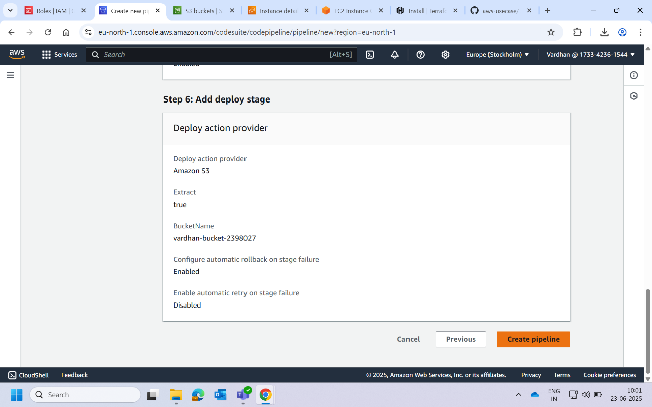

1. Pipeline will be created. You can watch multiple stages in pipeline.

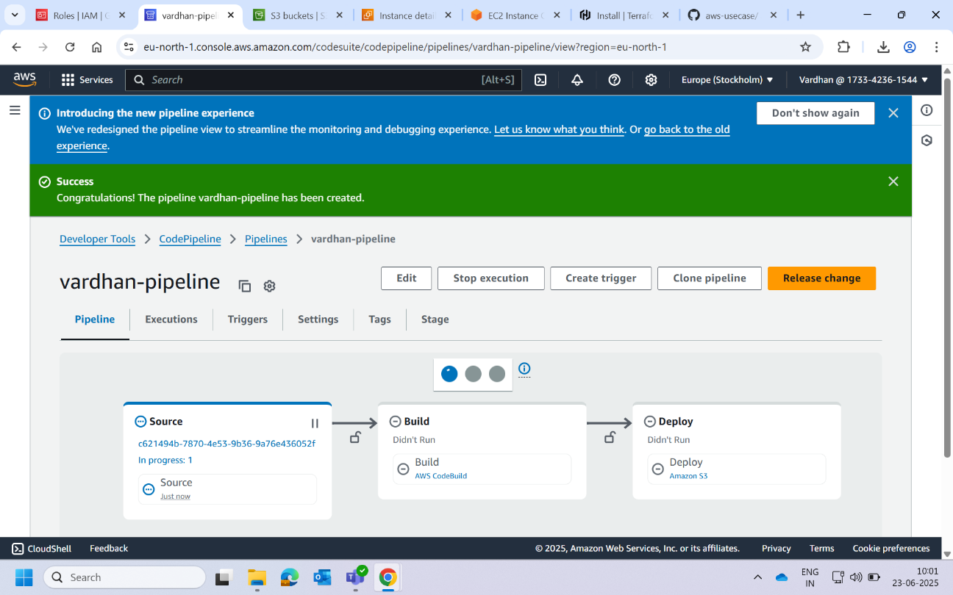

1. After all stages complete running, we can see three completion marks on top. The deployment was successful.

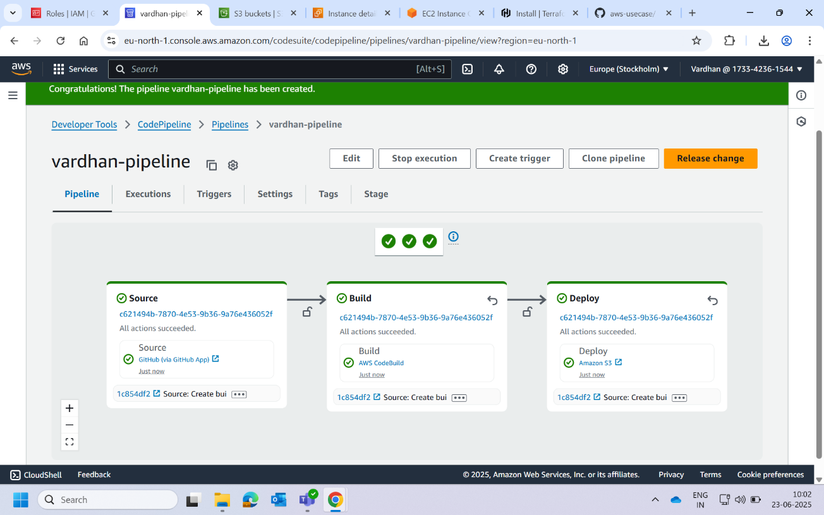

1. Now head to Amazon S3 and bucket we created. Go to properties and scroll down we find a link to access HTML file.

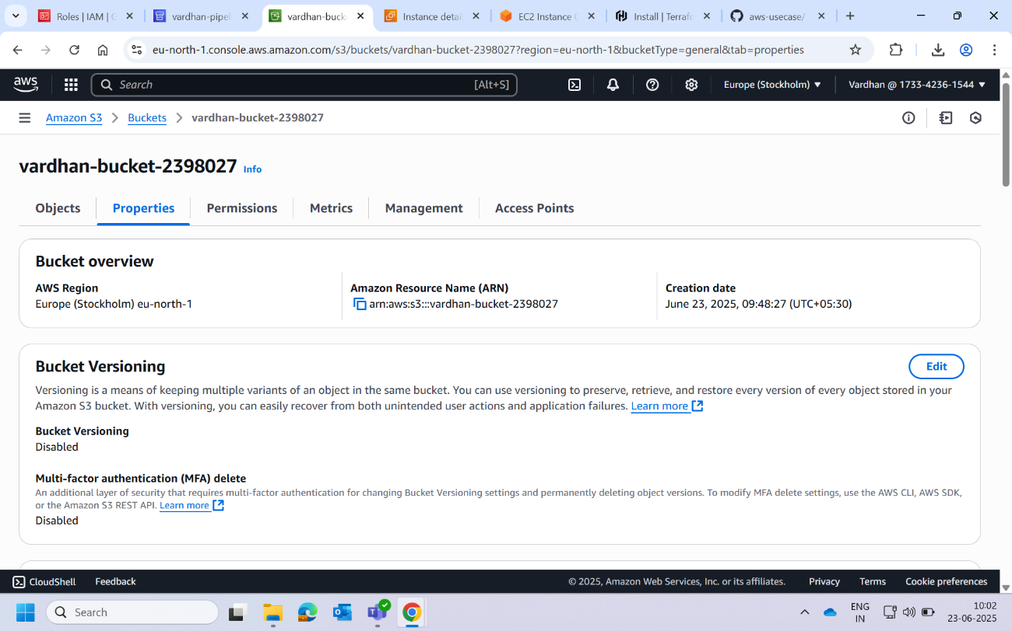

1. Now we can see our website. We can share this link publicly.

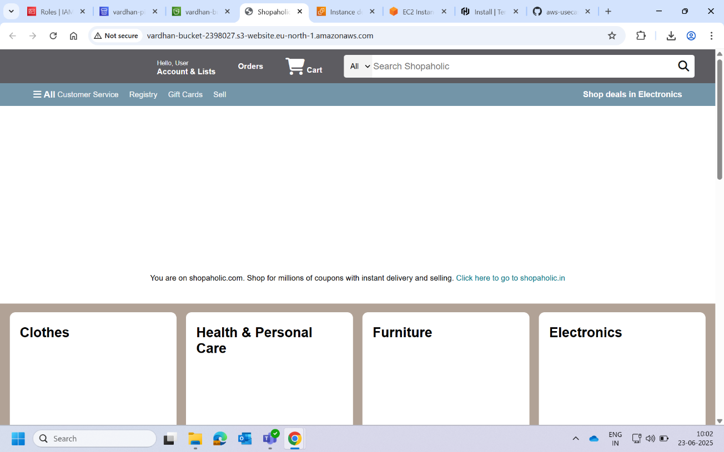

1. Now comes the major part. Make changes in the repository in github. I added a background image. Commit the changes.

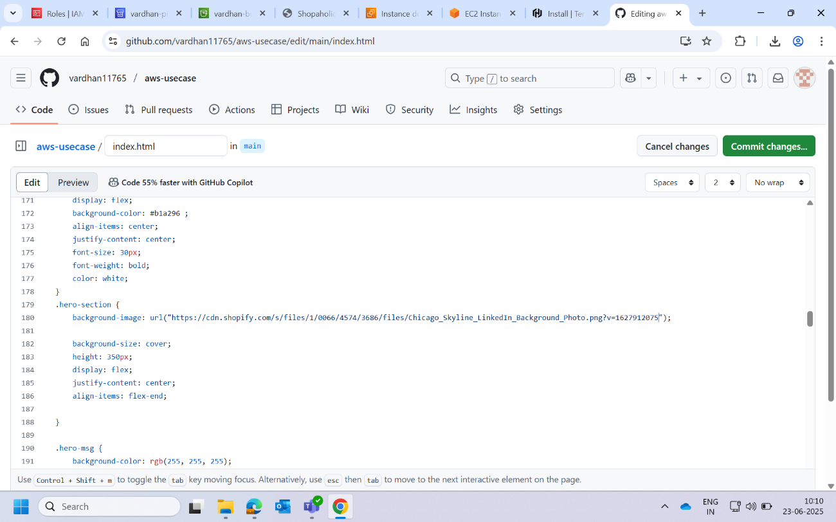

1. As we created a webhook we can see whole pipeline will run again. Wait for completion of all stages. This will deploy our project.

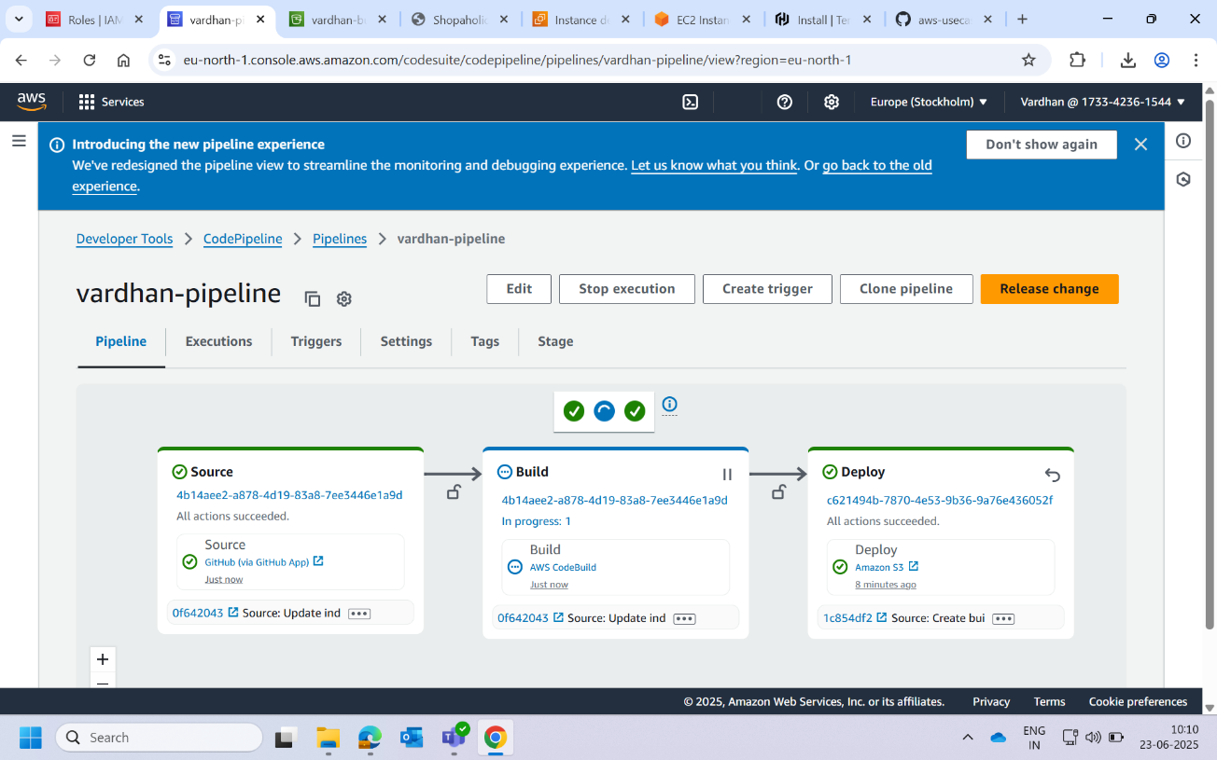

1. Now go to S3 link click on refresh we can see background image is added succefully.

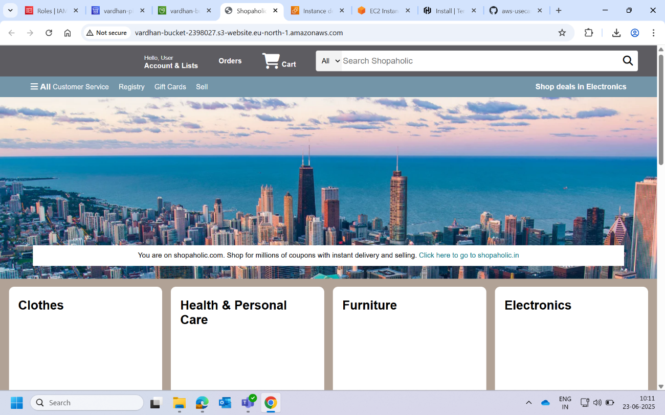

Finally, our task has been completed. We automated the deployment of simple static website to an S3 bucket, with changes automatically picked up using webhook and deployed through CI/CD pipeline. Used terraform to provision a S3 bucket and created IAM roles for AWS devops services.